Nurture Your Adrenals
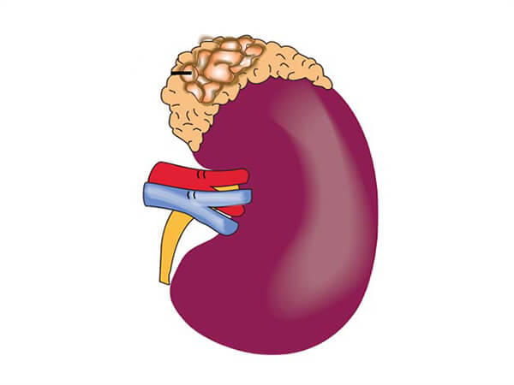
January 2021

What are the adrenal glands and what do they do?
Adrenals are glands that sit on top of each kidney and they secrete hormones that regulate important bodily functions and responses.
Adrenaline or epinephrine is a catecholamine, a fight or flight hormone secreted by your adrenal glands in times of stress. Epinephrine has a powerful affect on your heart, increasing blood pressure, heart rate and overall cardiac output. It also causes the liver to release glucose for additional energy needs. Another catecholamine is norepinephrine, which functions as a neurotransmitter. Norepinephrine is also a stress hormone that elicits constriction of blood vessels, increasing blood pressure, as well as stimulating the breakdown of fats to glucose for energy.

Other hormones produced by the adrenals include:
- Cortisol (Hydrocortisone) – regulates the metabolism of proteins, carbohydrates and fats into energy and has anti-inflammatory factors.
- Aldosterone – regulates reabsorption and secretion of important minerals and electrolytes in the body to help control blood volume and pressure.
- Sex Hormones – produce small amounts of male and female sex hormones. This becomes more important for menopausal and postmenopausal women whose ovaries no longer secrete estrogen or progesterone.

Why support your adrenal function?

Adrenals help us to deal with stressful situations when heightened attentiveness and greater energy are needed. In addition, they support strong immune function and general well being. Adrenal health is also beneficial for older women to provide hormonal balance. Often people with adrenal fatigue, due to chronic stress, feel fatigued, light-headed, achy and have low blood pressure.

Here’s what you can include to pump up those adrenals:
Foods containing omega 3 fatty acids:

- Flax seeds
- Chia seeds
- Walnuts

- Cold water fish – salmon, albacore tuna
- Fish oil supplements
- Mineralized salt - sea salt or Himalayan crystal salt - in your food and your drinking water to enable water to permeate cells.
- Include cinnamon and ginger to flavor foods
- Protein – preferably animal protein, with each meal

- Lower sugar fruits are ok – berries, kiwi and green apples
- Organic vegetables, lightly cooked is preferable
- Eat regular meals and snacks as necessary
- Get plenty of sleep and take a small nap in the early afternoon, if necessary.

Herbs to support your adrenals and overall ability to cope with stress:

- Ashwaganda
- Eleutro/Siberian Ginseng – see my blog!
- Gotu Kola
- Holy Basil/Tulsi
- Reishi mushroom
- Passionflower
- Rhodiola
- Shatavari
- Skullcap
- Wood Betony

Essential oils that support adrenal function
- Basil
- Geranium
- Rosemary
Essential oils that calm and quiet the mind:
- Lavender
- Sandalwood
- Vetiver

Here’s what you should avoid:

- Sugar – refined, added sugar and sugar substitutes, like aspartame and sucralose
✓Maple syrup or honey in limited amounts
✓Stevia, monk fruit, and xylitol
- Refined carbohydrates – foods made with white flour, such as cakes, breads, crackers
- High sugar fruits such as banana, papaya, mango and dried fruits
- Foods high in potassium such as bananas, all melons, dried fruits, oranges and grapefruit
- Caffeine is an adrenal stressor – cut down or avoid completely.
- Strenuous exercise, especially in temperatures below 40°F.

When your adrenals are functioning optimally, your immune system will be more responsive and effective, enabling improved overall health and a higher potential for greater strength and energy.

Photo by Rachel Philipson, Ithaca, 2020

