Nancy Corwin Malina, MS, CNS
NCM Nutrition, LLC
Ithaca, NY
Dairy Free Fact Sheet
What is dairy? Dairy includes all products made from milk of mammals. All milk contains the sugar lactose that is broken down and digested into galactose & glucose.

What does it mean to be lactose intolerant? People who are lactose intolerant lack the enzyme; lactase that is required to help humans digest milk and our ability to produce this enzyme, diminishes with age. People who are lactose intolerant often feel bloated and gassy when they consume dairy products. There are now lactose-free dairy products available to help combat such reactions.

What does it mean to be casein intolerant? Casein is the protein in milk. Different types of cows (from different species) produce one of two types of casein: A1 and A2. Cows, such as Holsteins (most common among cows in the US), produce milk with A1 beta casein. A1 beta casein contains beta casomorphins, specifically BCM-7 opioids. * Smaller cows of older breeds, such as Jersey cows, produce A2 beta casein, also found in human milk and for that matter, goat’s milk. Some humans are more sensitive to the A1 beta casein cow’s milk because it’s molecular structure actually contains a histamine amino acid, whereas the A2 in that same location contains another amino acid. In addition, the A1 beta casein, when it is processed and/or digested, releases BCM-7 opioid into the blood stream, it can cross the blood-brain barrier, the GI tract and is found in urine. People with sensitivity to A1 casein, often have red, inflamed itchy cheeks and eczema. More severe reactions have been linked to behavioral and mental health issues, including autism.** Other symptoms of dairy intolerance include sinus congestion, increased mucus production, constipation and gas. It is especially helpful to avoid dairy when you have a cold, sinus allergies or the flu because of increased mucus production.

Are there substitutions? If you suspect that you are sensitive to A1 casein, try dairy-free milks, yogurts, cheeses and ice creams made from flax, almonds, cashews or coconut. They are easily available and adaptable for various recipes.
What’s safe to eat?

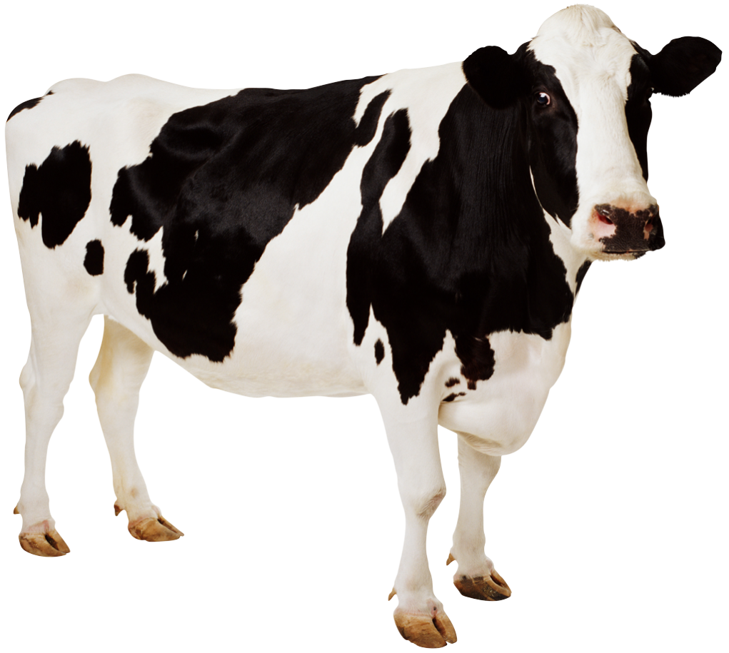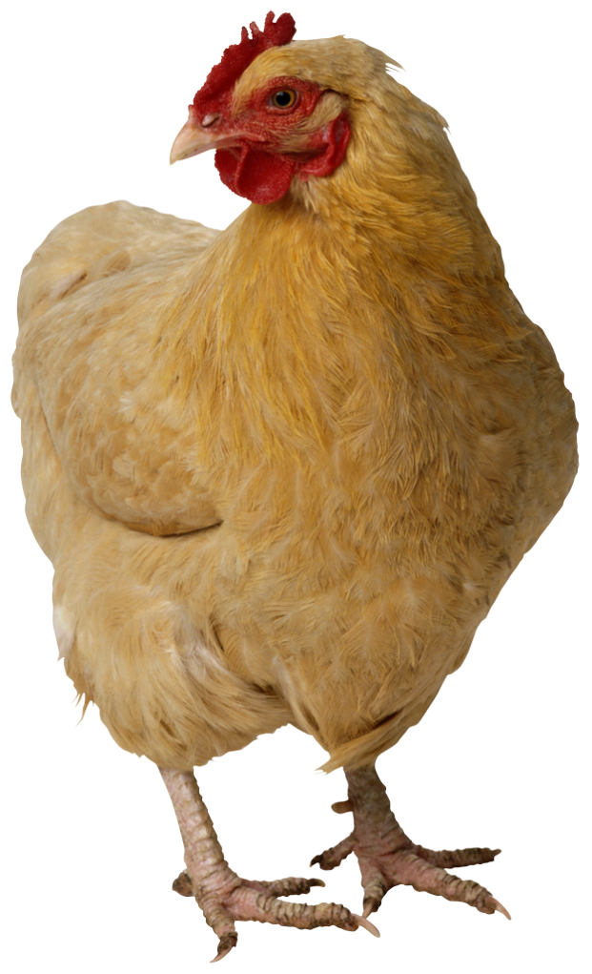Grass-fed meat, poultry & fish
Cage free eggs
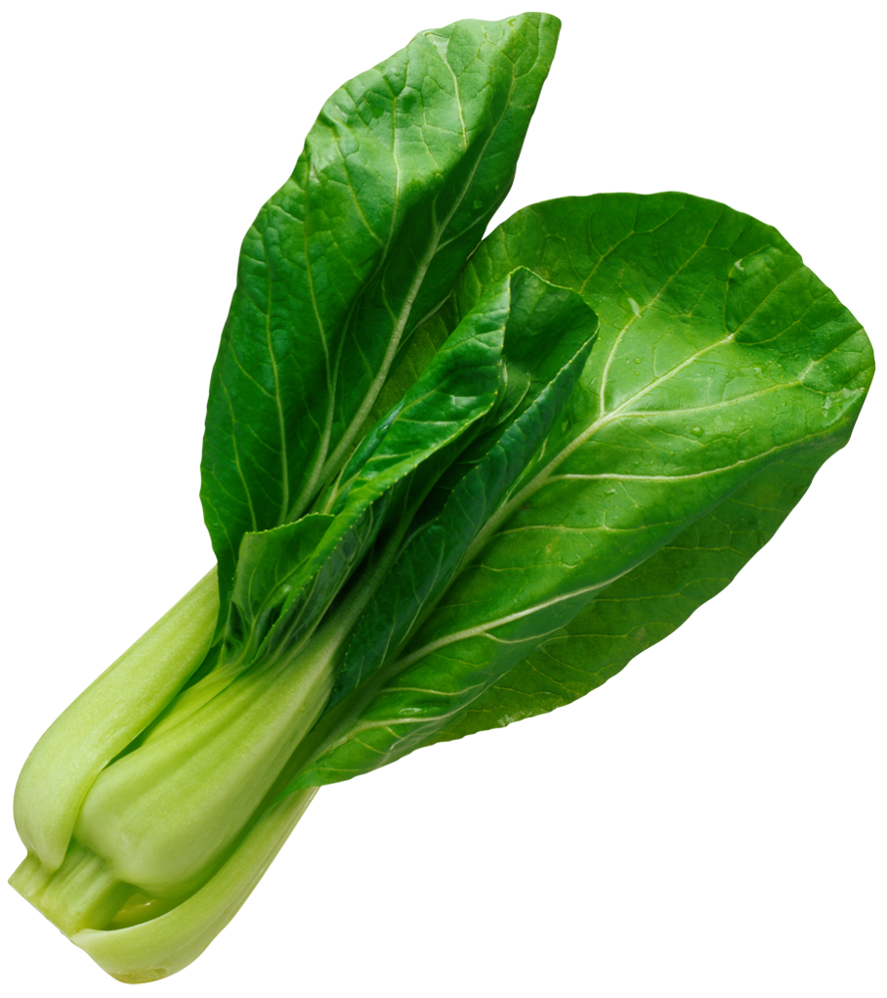Organic vegetables & fruits

Seeds & nuts
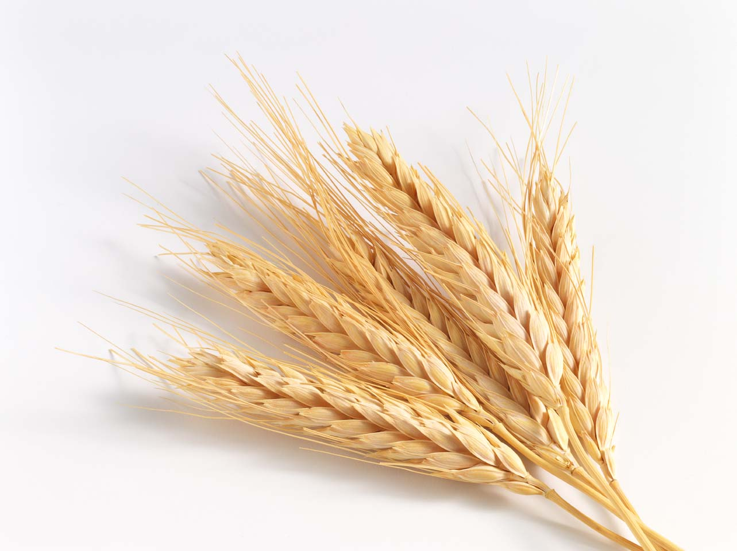Organic whole grains

Meal Suggestions

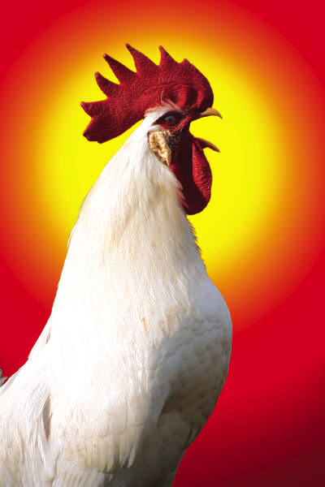Breakfast
Cage free eggs with vegetables
Smoothie with vegetables & fruit
Bread with nut butter spread
Grass fed sausage
Nut butter on apples, celery or pears

Lunch
Vegetable soup
Coconut milk based soups
Hummus with vegetables
Egg, tuna, chicken salads
Wraps with grilled beef, poultry or fish
Rice and beans with salsa

Dinner
Rice or quinoa pasta & tomato sauce
Crilled poultry, meat or fish
Meatloaf
Spagetti squash with sautéed vegetables
Rataouie
Beef stew with vegetables
Frittata with vegetables

*Hans Meisel and R. J. FitzGerald, Opioid peptides encrypted in intact milk protein sequences, British Journal of Nutrition (2000), 84, Suppl. 1, S27±S31

**Sokolov O¹, Kost N², Andreeva O², Korneeva E³, Meshavkin V², Tarakanova Y², Dadayan A⁴, Zolotarev Y⁴, Grachev S⁵, Mikheeva I³, Varlamov O⁶, Zozulya A². Autistic children display elevated urine levels of bovine casomorphin-7 immunoreactivity., Peptides. 2014 Jun;56:68-71. doi: 10.1016/j.peptides.2014.03.007. Epub 2014 March

